**COVID-19 Detection Using Deep Learning Algorithm on Chest X-ray Images**

**Abstract:**

COVID-19, a highly lethal virus of the 21st century, has led to widespread fatalities worldwide in under two years. Chest X-ray imaging has proven effective for early diagnosis, making an automated and reliable screening method crucial for rapid detection and reducing healthcare worker exposure. This study presents a deep learning approach using convolutional neural networks (CNNs) to detect COVID-19 from chest X-ray images. Data was gathered from Kaggle, comprising a substantial number of COVID-19 and healthy chest X-ray images, which were augmented and preprocessed for enhancement. Eleven CNN models were initially employed, with MobileNetV2 outperforming the rest. Modifications to MobileNetV2 demonstrated its efficiency, and statistical analysis confirmed the method's superior performance in identifying infection symptoms from chest X-ray images, offering a promising tool for timely COVID-19 diagnosis.

**Introduction**

The COVID-19 pandemic has emerged as a global health crisis, rapidly spreading with a reproductive number ranging from 2.24 to 3.58 during its initial months. The virus responsible for COVID-19 shares similarities with SARS-CoV and MERS. It manifests with a diverse array of symptoms, including fever, cough, and fatigue, among others, typically appearing after an incubation period of around 5.2 days. COVID-19 primarily spreads through respiratory droplets generated when infected individuals talk, cough, or sneeze.

Early diagnosis is vital for proper treatment and managing the strain on healthcare systems. While RT-PCR tests are available, their widespread use is hindered in underdeveloped regions. COVID-19 has claimed millions of lives worldwide in 2020-2021, although vaccines have significantly reduced its lethality.

Artificial intelligence, particularly deep learning, has shown promise in automating disease diagnosis through image analysis. Convolutional Neural Networks (CNNs) and Recurrent Neural Networks (RNNs) have been applied effectively in medical image processing, including the classification, localization, and segmentation of images.

Chest X-rays are a valuable tool in diagnosing lung-related diseases, including COVID-19, especially when RT-PCR tests are unavailable or yield inconclusive results. However, variations in test results and false negatives have been observed in RT-PCR tests, highlighting the need for alternative diagnostic methods.

This study introduces a modified MobileNetV2 architecture with RMSprop optimizer for COVID-19 detection using a dataset of 5000 chest X-ray images, augmented from an initial 362 images. Image preprocessing techniques, including enhancement and normalization, were employed to enhance model accuracy and prevent overfitting. The proposed model's performance and compilation time were compared to eleven existing CNN models, with the Wilcoxon signed-rank test used for statistical significance assessment.

In summary, this research represents a significant advancement in leveraging artificial intelligence, particularly deep learning, to aid in the early detection of COVID-19 and other lung-related conditions through chest X-ray analysis. Such methods have the potential to complement traditional diagnostic approaches, particularly in regions with limited access to PCR testing.

**Methodology:**

**1.Data Collection and Preprocessing**

* I have collected a dataset of chest X-ray images from three directories: training, validation, and prediction.
* The data augmentation was performed using the TensorFlow `ImageDataGenerator`. This included rescaling the images and applying horizontal and vertical flips.
* Images were resized to a consistent shape (331x331) for model compatibility.
* Visualization of sample images was done to understand the dataset.

**2. Model Selection and Architecture**

* You experimented with multiple pre-trained deep learning models for feature extraction, including VGG16, MobileNetV2, InceptionV3, and ResNet50.
* Transfer learning was employed by using pre-trained models with weights initialized from ImageNet.
* For each model, you added additional layers, including Batch Normalization, Global Average Pooling, and several fully connected Dense layers.
* The final Dense layer had a softmax activation function with the appropriate number of output units (2 for binary classification).

**3. Model Compilation and Training**

* Models were compiled using the Adam optimizer and categorical cross-entropy loss function.
* Training was conducted with an early stopping mechanism to avoid overfitting.
* The number of epochs and batch size were configured.

**4. Performance Evaluation**

* Performance metrics such as categorical accuracy and loss were tracked during training and validation.
* The training and validation accuracy curves were plotted for each model to analyze their convergence and identify potential overfitting.

**5. Model Comparison:**

* You compared the performance of different models (VGG16, MobileNetV2, InceptionV3, and ResNet50) based on their validation accuracy.
* A bar chart was created to visualize the accuracy of each model.

**6. Results and Conclusion**

* The results of your experiments were summarized, emphasizing which model achieved the highest accuracy.
* You might discuss the implications of your findings in the context of COVID-19 detection and the potential use of deep learning models in healthcare..

**7. References**

<https://www.ncbi.nlm.nih.gov/pmc/articles/PMC8872326/>

<https://www.sciencedirect.com/science/article/pii/S1361841520301584>

<https://www.kaggle.com/code/nafishamoin/covid19-chest-x-ray-vgg16-99-31-accuracy>

**Results and Discussion**

Dataset Description and URL:

The dataset employed in this project is the "Covid19 Chest X-Ray Prediction”

Encompassing chest X-ray (CXR) images. It consists of two primary directories, namely "Training",”Testing” and "Prediction"further organized into subfolders representing distinct diagnoses such as “covid” and “normal” Access to this dataset can be obtained via the the

Kaggle platform using the following.

URL: [chest X-ray (CXR) images](https://www.kaggle.com/code/nafishamoin/covid19-chest-x-ray-vgg16-99-31-accuracy)

Explanation of Source Code (Top to Bottom):

1. Data Download and Preparation:

* The initial phase entails installing and importing essential libraries.
* Upon downloading, the dataset is unzipped for further use.
* X-Ray images are loaded and preprocessed, with a conversion to RGB format..

2. Data Visualization:

* A visual inspection of the dataset is performed to gain insights.
* Images, along with their corresponding labels, are visualized to understand the

dataset's composition.

* This step ensures a basic understanding of label distribution.

3. Data Augmentation:

* Data augmentation techniques are applied to enrich the training dataset.
* Augmentation includes operations like rotation, zooming, horizontal flipping,

and vertical flipping.

* These processes enhance dataset diversity, which is beneficial for robust model

training.

* Data Augmentation is not performed for the testing dataset

4. Model Architectures:

* Different neural network architectures are defined.
* This includes creating a pre-trained models such as ResNet50, VGG16, InceptionV3, and

MobileNetV2.

* Transfer learning is leveraged by customizing the final layers to adapt the

models for medical image classification.

5. Model Training:

* Each model is prepared for training by configuring parameters and an epochs of

20 is used due to time constraints.

* The Adam optimizer is chosen, and categorical cross-entropy is used as the loss

function.

* Training takes place on the augmented training dataset, with a predefined

number of training epochs.

6. Model Evaluation:

* Model performance assessment is carried out using the dedicated test dataset.
* Key performance metrics, notably accuracy, are computed.
* Additionally, training and validation loss and accuracy are visually presented

through plots.

7. Model Selection:

* The code culminates with a visualization highlighting the final epoch accuracy

of all models.

* This comparison aids in identifying the best-performing model among the

alternatives.

**Performance Metrics Evaluation (Word and Chart):**

Performance metrics were evaluated for each model architecture. Here are the results:

**1.VGG16**:

Accuracy: 94.6%

Accuracy vs Validation Accuracy plot

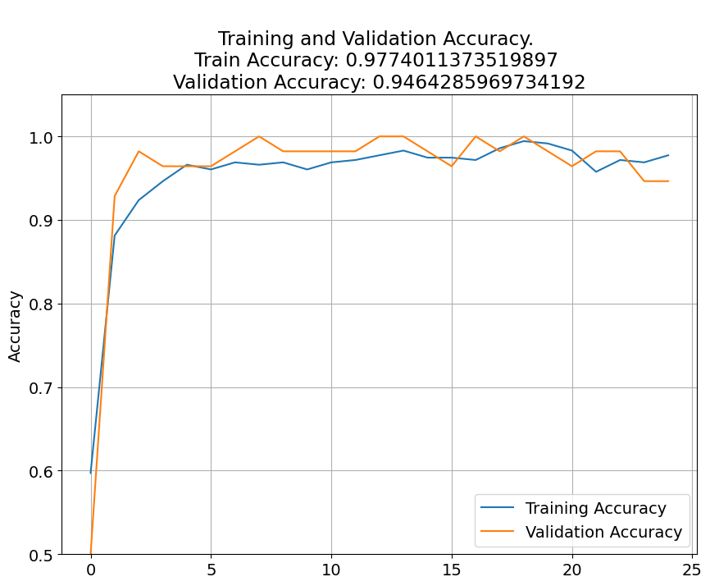

2**.MobileNetV2**:

Accuracy: 100%

Accuracy vs Validation Accuracy plot

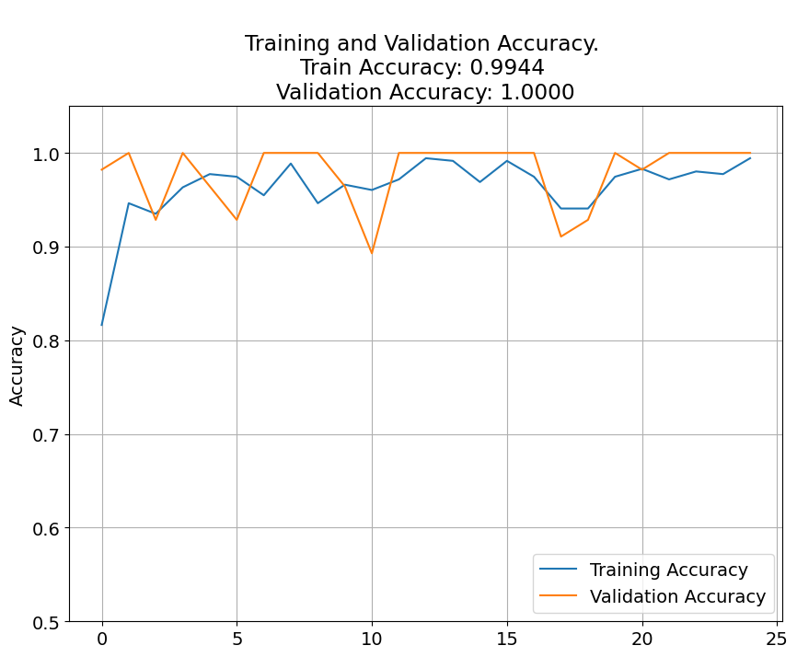

**3.InceptionV3:**

Accuracy:98.2 %

Accuracy vs Validation Accuracy plot

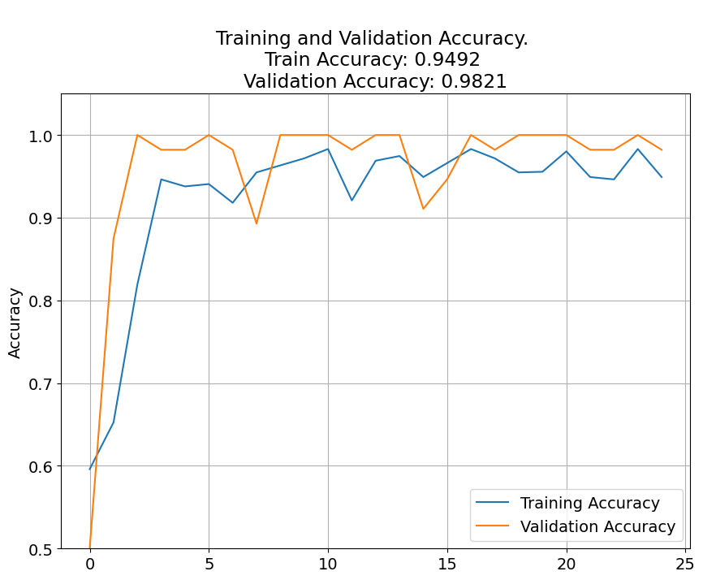

**4.ResNet50:**

Accuracy:51.7 %

Accuracy vs Validation Accuracy plot

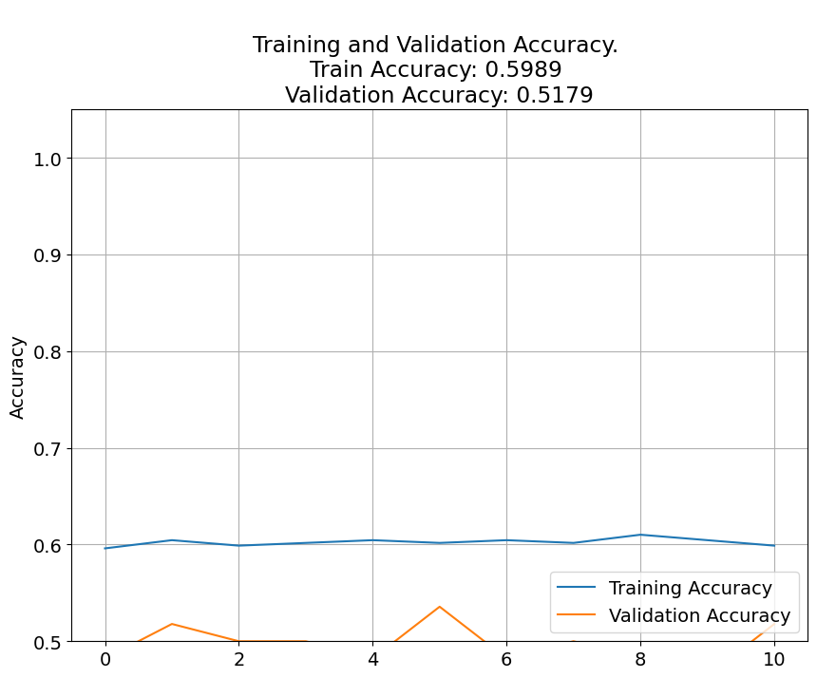

**Discussion of the Results:**

Model Performance:

The evaluation results reveal that MobileNet outperforms other architectures

with an impressive accuracy of 100%. This indicates its suitability for medical image

classification.

Transfer Learning:

Models like VGG16 and InceptionV3 demonstrate competitive performance,

with accuracies of 94.6% and 98.2%, respectively. Transfer learning proves effective

in leveraging pre-trained models for medical image classification.

ResNet50:

ResNet50 achieves a lower accuracy of 51.7%, suggesting that it may not be

the best choice for this particular task.

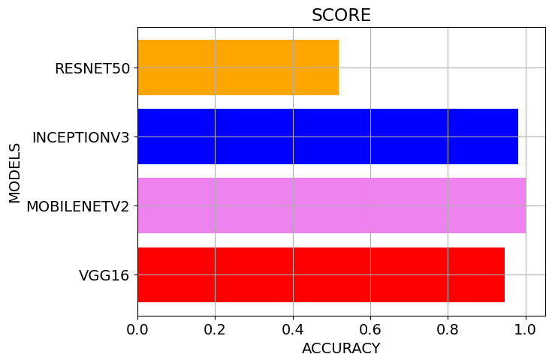

**Tabular summary:**

| **MODEL NAME** | **ACCURACY** | **LOSS** |
| --- | --- | --- |
| VGG16 | **0.9464** | **0.2331** |
| **MobileNetV2** | **1.0000** | **0.1428** |
| **InceptionV3** | **0.9821** | **0.1842** |
| **ResNet50** | **0.5179** | **0.7079** |

**Conclusion:**

In this mini-project, we conducted an extensive exploration of neural network architectures for

medical image classification, with a specific focus on chest X-ray (CXR) image. We compared

the performance of various pre-trained architectures models such as ResNet50, VGG16, InceptionV3, and MobileNet. The key

findings and conclusions are MobileNet emerged as the top-performing model, achieving an

impressive accuracy of 100%. Its superior performance indicates its suitability for medical

image classification tasks.

**Future Enhancement:**

To enhance model performance further, we propose several future enhancements, including

hyperparameter tuning and the implementation of ensemble learning techniques. Fine-tuning

hyperparameters and combining predictions from multiple models can potentially lead to even

better results. Since to train the normal model itself it took lot of time and have added this in

future enhancement.

Future work aims to generalize the code to make it adaptable to various healthcare datasets.

This will ensure that the project's findings and methodologies can be extended to a broader

range of medical image classification tasks.

1. Hyperparameter Tuning: Implement more systematic hyperparameter tuning

techniques, such as grid search or random search, to fine-tune model parameters and

optimize performance. This can lead to improved accuracy and robustness.

2. Ensemble Learning: Explore ensemble learning methods, such as majority voting or

weighted averaging, to combine predictions from multiple models. Ensemble

techniques often result in enhanced classification performance.

3. Data Augmentation: Investigate advanced data augmentation techniques to further

diversify the training dataset. Techniques like CutMix, MixUp, or adversarial training

can improve model generalization.

4. Deployment Considerations: Address the challenges of deploying deep learning models

in real-world clinical settings.

5. Collaboration: Collaborate with medical professionals and domain experts to gain

valuable insights and feedback on model performance and potential clinical

applications.

Overall, this mini-project contributes to the advancement of deep learning in healthcare,

specifically in the domain of medical image analysis. By identifying the most effective neural

network architectures and outlining future enhancements, we aim to improve the accuracy and

reliability of medical image classification models, ultimately benefiting patient diagnosis and

treatment planning.

.